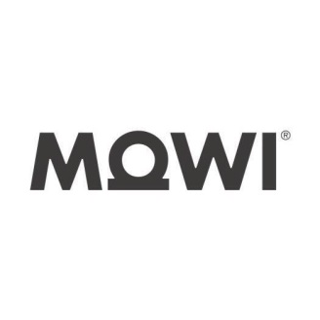
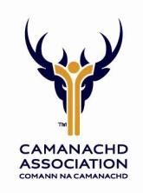
MOWI YOUTH
DEVELOPMENT FUND

APPLICATION GUIDELINES 2024

The MOWI Development Fund represents a partnership between The Camanachd Association and MOWI.

The Children and Young Persons Development Fund aims to increase opportunities and participation at accredited member Clubs by providing a maximum grant award of £500. The funding will be eligible for accredited member clubs who are proposing new or enhanced initiatives to develop shinty for children and young people (up to age 18).
It is a competitive application process with a total annual awards budget of £5000. All applications will be considered by the Youth Development Committee and funding awards will be prioritised in support of those proposals that best meet the stated aims and criteria of the scheme. Furthermore, all applications will be notified of the outcome within 30 days of the submission date.

Eligibility Criteria
The Fund is intended to support sustainable initiatives targeted an increase in child and young person’s participation in shinty.
- All Clubs applying must be current members of The Camanachd Association and accredited through the Clubmark Accreditation Scheme.
- All Clubs applying must have an approved Child Protection & Equality Policies and a named Child Protection Officer.
- Applications must demonstrate clear growth in the number of young people (Up to age 18) playing shinty and/or the quality of provision available as a result of the initiative. Applications must be presented with a clear plan for sustaining projects that are being funded.
- Applications must show how the impact of the project will be measured; also how any increased participation numbers will be sustained once the grant funding has been spent.
- Although applications to fully fund projects will be considered, priority will be given to those that show additional cash funding for their initiative from alternative sources such as Awards for All.
- Clubs can only receive one award each calendar year.

Please note: an application is not guaranteed to be successful and the level of demand for the Fund makes it likely the Youth Development Committee will not be able to fulfil all requests for funding received each year.

Types of Project – In line with CA priorities for 2024 -

Examples of the types of projects for which funding is available can include:
- Girls only camps/festivals or other initiatives focused on increasing the participation of women and girls.
- Recruitment, training and development of additional volunteers, youth coaches and/or referees to increase the club’s capacity for participation and promotion through the club Accreditation scheme.
- Purchase of additional equipment to enable increased participation – this would not apply to established clubs.
- Enhanced promotional activity targeted at increasing participation e.g. summer camps
- Club Open Days- engaging the whole community

Application Process

- Interested clubs should discuss their proposed application with their Regional Development Officer in advance of submission.
- Clubs should submit their completed application and all supporting material by the date specified on the Application Form.
- Following submission and prior to consideration by the Youth Development Committee, clubs may be contacted to provide clarification and further detail regarding the content of their application.
- All applications will be considered by the Youth Development Committee and clubs will be notified of the outcome within 30 days of the submission date.

Funding Conditions

- Successful applicants will be required to sign an Award Agreement Letter prior to the project commencing, also to return an Outcome Report within three months of the project completion.
- The Camanachd Association may withhold or reclaim funding from any club should the activity delivered differ from that proposed in the original application, unless agreed in writing by the Camanachd Association.
- The Camanachd Association may withhold or reclaim funding from any club that ceases to be a member of the Camanachd Association during the period of the project.

Contact details:

Ronald Ross – Ronald.ross@shinty.com

