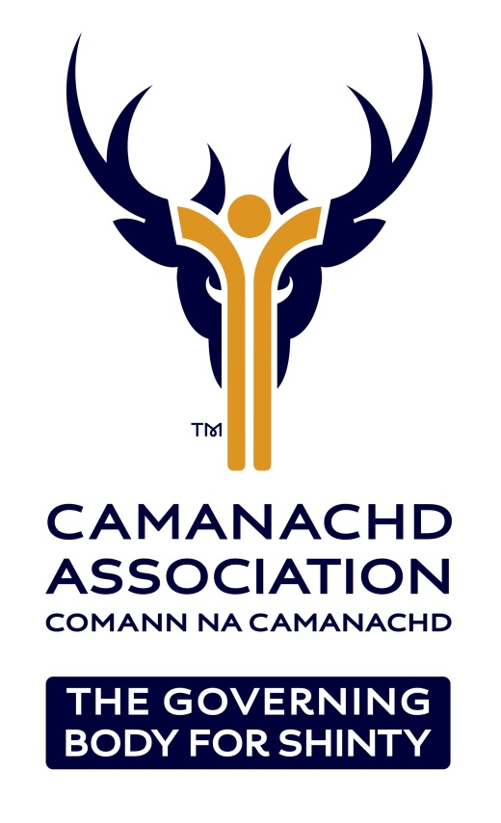

DIVERSITY AND INCLUSION POLICY

Ensuring access for all

Policy Adopted 27th March 2013
Policy updated and approved by C.A Board 5th March 2015
Policy updated and approved by C.A Board 31st January 2018

- Statement of Intent

1.1 The Camanachd Association will endeavour through our policies, procedures, actions and decision-making to ensure that no employee, volunteer or member receives less favourable treatment on the grounds of age, sex, gender identity, disability, marital or civil partnership status, pregnancy or maternity, religion, race, ethnic origin, nationality, socioeconomic status or sexual orientation.

  - In addition The Camanachd Association recognises that we live in a diverse society and will endeavour to ensure that all employees, volunteers and members are given the same opportunity regardless of their socio-economic background.

  - The Camanachd Association is committed to ensuring equitable access to Camanachd and fair treatment for all who wish to participate.

- Purpose Of The Policy

  - The Camanachd Association recognises that certain sections of the community have been affected by past discrimination and may be denied the opportunity to participate equally and fully in sport at all levels.

  - This policy has been produced to prevent/tackle any potential/current discrimination or other unfair treatment, whether intentional or unintentional, direct or indirect, against its employees, members and volunteers; and

  - To ensure that people have a genuine and equal opportunity to participate to the full extent of their own ambitions and abilities, without regard to their age, sex, gender identity, disability, marital or civil partnership status, pregnancy or maternity, religion, race, ethnic origin, socioeconomic status or sexual orientation;

- Actions

  - The Camanachd Association will produce and maintain an action plan to ensure the intent of this policy is delivered.

  - All areas of the organisation will be affected by this action plan, which will be incorporated in to the overall business delivery plan, itself reviewed and updated on an annual basis.

  - The Camanachd Association recognises that, in some cases, to achieve the principle of equality, unequal effort is required and, if appropriate, will consider positive action to tackle under-representation.

- Legal Requirements
- Additional to the intent set out within this policy, The Camanachd Association recognises its obligations in relation to the Equality Act 2010. The Camanachd Association will continue to update the policy in response to new legislation to ensure that it continues to comply with all legal requirements.

- Discrimination, Harassment and Victimisation

5.1 Discrimination can take the following forms:

    - Direct Discrimination. This means treating someone less favourably than you would treat others in the same circumstances.

    - Indirect Discrimination. This occurs when a criterion or practice is applied to an individual or group that would put persons of a particular characteristic at a particular disadvantage compared with other persons.

    - Harassment is described as unwanted conduct relating to a protected characteristic that has the purpose or effect of violating a person’s dignity, or which creates an intimidating or hostile, degrading, humiliating or offensive environment for that person.

    - Victimisation is defined as when someone is treated less favourably than others because they have taken action under the Equality Act 2010 or they have helped another person to do so.
    - Bullying is defined as a form of personal harassment involving the misuse of power, influence or position to persistently criticise, humiliate or undermine an individual
  - The Camanachd Association regards discrimination, harassment or victimisation, as described above, as serious misconduct and any employee, volunteer or member who discriminates against, harasses or victimises any other person will be liable to appropriate disciplinary action.

Responsibility, Implementation and Communication

  - The following responsibilities will apply:

    - The Board of Directors is responsible for ensuring that this Diversity Policy is followed.

    - The Chief Executive Officer has the overall responsibility for the implementation of the Policy and the Action Plan.

    - The Diversity and Inclusion Policy will be implemented immediately following Board agreement and, at a corporate level, will result in the following:

    - A copy of this document will be available to all staff (both permanent and contract), members and volunteers of The Camanachd Association.

    - The Camanachd Association will take measures to ensure that its employment practices are non-discriminatory.

    - No job applicant will be placed at a disadvantage by requirements or conditions which are not necessary to the performance of the job or which constitute unfair discrimination.

    - A planned approach will be adopted to eliminate barriers, which discriminate.

    - Consultants and advisers used by The Camanachd Association will need to demonstrate their commitment to the principles and practice of equality and that they abide by this policy.

  - The Diversity and Inclusion Policy will be communicated in the following ways:

    - The Policy will be part of the staff handbook.

    - It will be covered in all staff and volunteer induction training.

    - All members will be made aware of the policy’s existence when they join and a summary of any revisions will be published in The Camanachd Association member communications.

    - It will be available on The Camanachd Association Website.

    - At time of review, a mechanism will be put in place to allow all staff, members and volunteers to be part of the process.

Monitoring and Evaluation

  - Once approved, the policy will apply for 3 years before a formal review takes place, unless any proposal to the Board, or legislation change, requires an interim review and/or amendment.

  - The Diversity and Inclusion action plan, created to ensure the intent of the policy is delivered, will be reviewed by the Chief Executive Officer and the member of staff with the responsibility for its implementation, on a six-monthly basis.

  - On an annual basis, statistical information will be produced by the Chief Executive Officer for the Board, and will be published internally and externally, to show the impact of this policy.

Disciplinary and Grievance Procedures

  - The principles of equality outlined in this policy sit within the wider ethical framework as delineated in The Camanachd Association Memorandum & Articles.

  - In accordance with The Camanachd Association policies & procedures an employee, volunteer or member who believes he/she has suffered inequitable treatment within the scope of this policy may raise the matter through The Camanachd Association’s Behaviour in Sport Committee.

  - Appeals of initial findings are provided for through The Camanachd Association Appeals Policy and Procedure.

