WCA SHINTY GUIDELINES 2016

Competition | No of Players | No.of substitutes | Duration of each half
National Div 1 | 10 | 4 | 40mins
North Div 2 | 8 | 4 | 35mins
Southth Div 2 | 8 | 4 | 35mins
Valerie Fraser | 10 | 4 | 40mins
Challenge Cup | 8 | 4 | 35mins

- All clubs will play league matches on a home and away basis.
- Medals will be awarded to the winners of each league.
- Winners of North Division 2 and South Division 2 automatically get promoted to the National League the following season. Where the winners are a 2nd team this rule will not apply.
- Games to be played on a Sunday (Skye,Glenurquhart and Lewis play their HOME games on a Saturday or mutually agreed day)
- All games to be played on the set dates.
- Games can only be re-scheduled for poor weather or bereavement. A rescheduled date MUST be agreed at the time of informing the WCA. Games can be played midweek with prior agreement of the WCA.
- Any problems with games MUST go through the WCA. The WCA will call the final decision.
- If games are cancelled without informing the WCA, the game will be deemed played and neither team will receive the points.
- If games are cancelled for any other reason than weather/pitch/bereavement, the team will be deducted one point and the game will still be required to be played and rescheduled by the WCA. (if cancelled a second time by the same team points awarded to the opposition)
- Cup competitions CANNOT be rescheduled by clubs and must be played on the dates given by the WCA. If extenuating circumstances lead to a postponement, the WCA will set the new cup tie date
- Throw up times to be between 1pm and 3pm (unless mutually agreed by both teams. If playing on a Saturday teams to be understanding of organising around men’s games and permitted to be between 12 and 4pm. A team will forfeit the points if they are more than 30mins later than the throw up time unless there are extenuating circumstances. In this instance, the travelling team must contact the home team as soon as possible before the throw up time. In Division 1, teams can commence play with a minimum of 8 players present and ready to play while division 2 require a minimum of 6

Player Registration

- All players must be registered with the Camanachd Association in order to be eligible to play (contact the CA office in Inverness to arrange this.) An unregistered player is not permitted to participate in any match MUST also notify the WCA either by phone or email of players you have registered before they play their first game.

Clubs With Teams in Divisions 1 , 2 & Development

Clubs with teams in both division 1 and 2 must name 8 division 1 players who are only permitted to play Division 1 games and must not play or be sub in any division 2 games. Also, any player who played in the Shinty/Camogie International is not eligible to play for their second team. Clubs entering a team in North or South 2 and a team in the development league must name 6 players for their Division 2 team who are only permitted to play in North/South 2. Players who have played in the International or North/South senior game are not permitted to play in the development league.

The Home Team is liable for;
- Arranging a suitable sized pitch for the fixture - dimensions below
- Organising a referee for the fixture
- Notifying the visiting team and the WCA if the pitch is unplayable
- Notifying the WCA of throw up times for the games
- Sending the team lines, match result and referees report (with goals scorers clearly marked) to the fixtures secretary as soon as possible
- Notify the WCA immediately of any postponements or cancellations of fixtures.
- Providing refreshments for the visiting team following a match
Team lines

- Team lines MUST be submitted BEFORE a match begins; 1 to the referee, 1 to the opposing team and 1 copy is retained. Team lines do not have to be written on official Camanachd Team Lines sheets but can be written by hand or printed out from a computer. (WCA blank will be attached) However, team lines must include the following information
- Competition e.g. WCA League Division 2 / Valerie Fraser Camanachd Cup
- Venue
- Home team v visitors
- Jersey number, name of player and their membership number (substitutes must be written separately below the list of starting players)
- Signature of secretary or match captain with name of club
- It is the responsibility of home teams to ensure that 1 copy of the team lines along with the referee match report are sent to the fixtures secretary within 14 days of the match being played.

Length of Games
- National 1 – 40 minutes each way
- Division 2 – 35 minutes each way
- Development league – short games played on round robin basis
- Valerie Fraser Camanachd Cup – 40 each way, 10mins each way extra time before penalties. Each team taking 5 penalties.
- Challenge Cup – 35 each way, 10mins each way extra time before penalties. Each team taking 5 penalties.

Eligibility of Players
Team lines will be checked therefore all teams must make sure their players are registered with the Camanachd Association. Any team fielding an unregistered player during a fixture will have the points awarded against them. An unregistered player is not permitted to participate in any match. Teams must also adhere to the ‘named player rule mentioned above’

Discipline

- Any player being booked during a match should be noted by the referee on the match report and the fixtures secretary informed asap. Sanctions for cards are as follows:
- 1 yellow card = warning
- 2 yellow cards = 1 match suspension (every 2 yellow cards equate to one red card)
- 1 red card = 1 match suspension
- 2 red cards = 2 match suspension etc.
- Cards will operate under at totting up for that season but will not be carried forward to the next season except any unfulfilled match suspensions

Pitch Dimensions

Pitches should be within the dimensions below and should be free from debris e.g. rubbish, syringes, dog faeces, glass, metal etc. No team should play on a pitch if there is any debris present until it has been safely removed and disposed of to the satisfaction of the referee.

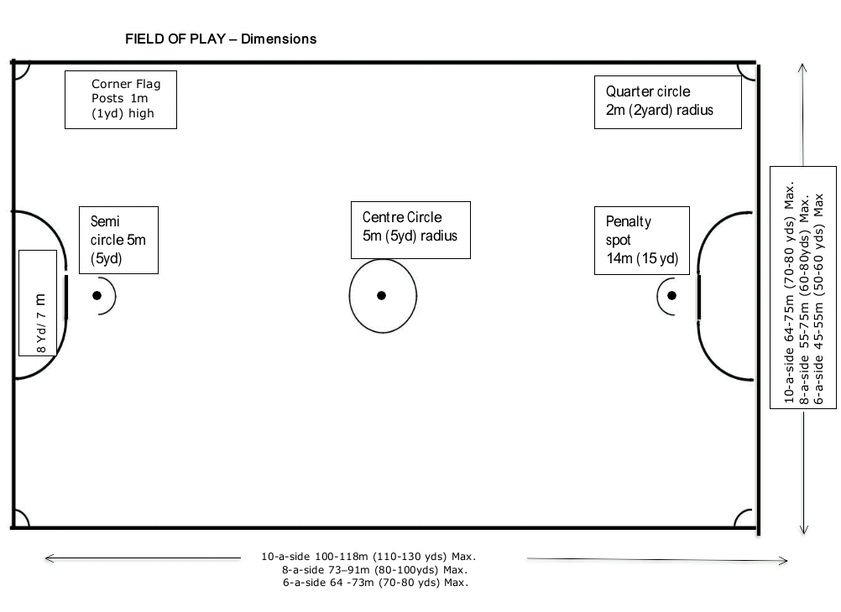

Contacts:-

Marion Gillies - WCA Secretary - 07958041450 - womens.shinty@gmail.com

Astie Cameron (Player Registration) - 01463 715931

Club Contacts Attached

