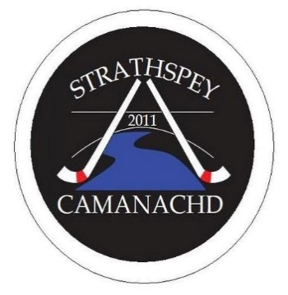
Strathspey Camanachd - Club Development Officer

- Location: Grantown on Spey
- Hours: 15 hours per week with a flexible work pattern
- Salary: £10,000 P/A
- Period of Contract: 4 years - commencing September 2021
- Location: Grantown on Spey and surrounding area.

Strathspey Camanachd is a forward-thinking club, affiliated with the Camanachd Association (Governing Body for Shinty). As a club they are committed to the promotion of equality of opportunity. It intends that no job applicant or employee shall receive less favourable treatment because of sex, marital or family status, age, ethnic origin, disability, race, colour, nationality, religion or belief, sexual orientation, or any other non - job related factor. Through adopting the Camanachd Association’s Equal Opportunities Policy and its implementation, Strathspey Camanachd would seek to ensure that the talents and skills of the successful applicant are utilised to the full, to the benefit of the club.

Strathspey Camanachd in partnership with Sportscotland and their Direct Club Investment Funding, wish to appoint a Shinty Development Officer specifically for the club promoting and implementing their Club Development Plan for the promotion and development of shinty in the Badenoch, Moray and Speyside areas. This is an important role with a particular emphasis on Youth Development, Club & Volunteer Development and membership increase and retention. The successful applicant will work with partners to grow the youth and family membership of Strathspey Camanachd, source new volunteers and promote new, inclusive pathways to club shinty.

This is a challenging role that would suit an individual with a strong “can do” approach to their work, a good understanding of the challenges and solutions to sports development and a passion for sports participation. The successful candidate will require excellent communication skills and should be well organised.

Interested individuals should submit an up to date CV and covering letter detailing your experience, skills, qualities and suitability for the role to Club president Charles Young. Applications to be emailed to shintylads@hotmail.com

The closing date for applications is 7th August Interviews will be held on the week beginning the 16th August 2021.

Informal enquiries in advance can be directed to Charles Young on; 07831 754750
