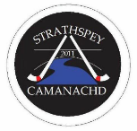Strathspey Camanachd Development Plan
(2021-2024)

- Aims for 2021
The club as a whole hope to work on the following over the coming year:
- Recover from the lack of shinty due to the Coronavirus “lockdown”.
- Build on the number of participants we have and increase numbers.
- Work on promotion within the local area to engage the community more in the sport. In particular, there is a desire to involve communities out-with Grantown.
- Increase the link with the Grantown Grammar school, trying to promote Shinty within the school.
- To host a shinty festival day, with mini competition for local primary schools and stage other junior matches and events.
- Hosting a level one coaching course.
- Look to work with both Primary and Secondary schools and local juniors with the aim of re-introducing an under 14 team and introducing an under 17s team for the 2022 season.
- Build on our existing links with the High Life Highland Active Schools Co-ordinator, the Craig MacLean Centre and other local organisations in order to promote the sport and our club.
Men’s senior team specific
- Continue to build on training and look to win the North Division Two league
- Continue to develop older juniors, giving them the opportunity where possible to push into the senior team as the season goes on
Ladies team specific
- Aim to fulfil every fixture
- Increase membership by promoting the sport more and getting more ladies involved
- Aim to finish mid table
- Looking to work with younger girls to increase junior girl participation in the sport
- Confirm a new manager / coaches for the women’s team.
Junior team specific
- Continue to build on our relationship with Grantown Primary.
- Strengthen link with local Grantown secondary school
- Re introduce an under 14s team
- Introduce an under 17s development team
- Encourage more girls to experience the sport from primary level onwards via girl only sessions/teams as well as mixed ones.
- Improve the pathway for players from primary through to adult shinty within the club
- Look at expanding our catchment area to include 4 other primary schools in 2021
- Ensure that we are being inclusive by being in a position to give every junior player a stick, ball and helmet of their own.
Community
- Aim to raise our profile within the community as a welcoming, well run and inclusive club that the community are proud of.
- Have a presence within the community at local events and are supportive towards community activities.
- Develop our links with other local voluntary and charitable organisations.
2. Summary of Club History and Development
The club was founded in 2011 by a group of young people in the locality of Grantown with a shared interest in the sport of shinty. Only one had any experience of playing the game, and he managed to gather enough support to start a development team which he trained himself.
The popularity of the sport grew quickly and in 2012 the club entered its first team into the competitive North Two Division. In the early years a local farmer offered the club a field which they used as their pitch, taking on the challenge of maintaining it themselves.
In 2014 the club moved to their current playing location of the Grantown Grammar School Pitch. The new pitch is maintained by the Highland Council, although it is lined by the club itself. Using this facility, also allows access to changing rooms.
The club continued to grow introducing a Ladies team in 2015 who went on to win the North Division League in 2017. They subsequently were relegated again after the 2019 season and were due to play back in the North Division League for 2020. In 2020 the club was provided with storage facilities close to the pitch by the local Scout Group.
Alongside the playing of the sport the club committee was traditionally formed by players themselves. However, over the years more and more volunteers from out-with the playing circle have got involved and the committee is now made up of a good balance of players / non players and coaches. Grantown is a very strong community and the club is in the heart of it. Matches have always been offered free of charge to spectators which has provided a positive family friendly atmosphere. Many of the club’s sponsors are shops in the community who offer help to the club through their services rather than financial aid.
In 2017 we formed our first Under 14 squad, which consisted of players mainly from the Grantown and Aviemore areas. Over the years maintaining the squad has been difficult with more established players committed to other clubs and a lack of volunteers and coaches from the local community to be able to offer a good competitive structure for players to get involved with.
In order to develop a sustainable club it has been recognised that we need to have a vibrant junior section and the club is currently concentrating on developing this area. Over the last 8 months we have been working hard on our links with the local primary and secondary school (both based in Grantown on Spey) to put connections in place which will provide a smoother pathway for children starting in Primary to filter in to the club’s under 14 and under 17 sections and eventually in to the adult game. The next step in this development is to expand into all the other local schools.
3. Present Situation Analysis
The following is an analysis of the current club structure and activities based on the sportscotland clubs and communities Framework.
3.1 Places
The club has been based at Grantown Grammar School Pitch since 2014. The pitch is maintained by the Highland Council and bookings are made through the local sports centre in conjunction with the school. The club is responsible for the lining of the pitch on match days. The club pay for each time they use the pitch for both adult matches and training. Junior training is booked through active schools and is free. However, the club pays for junior matches. The secondary school has the final say on whether the pitch is playable or not.
Alongside the pitch we may use the sports centre’s outdoor changing rooms. Storage of equipment is in the local scout hut which is located at the back of the pitch. We do not pay for storage but instead work with the scouts to help them with coaching and building maintenance.
The club does not have a clubhouse or onsite catering facilities. After match soup and sandwiches are available at the local pub for adult matches.
3.2 People
A small committee is responsible for overseeing the running of the club. However, there is a wider group of volunteers who help the club in various areas. Including coaching, pitch lining, fund-raising, administration and child protection. The club has recently hosted a level one coaching course and now have a team of 9 qualified coaches. The structure is interlinked from the first team down through the ladies, youth and into the primary school ages.
3.3 Profile
The club has a good profile within the local area, engaging with both schools in Grantown (primary and secondary), active schools, the leisure centre, Highland Council, community council, local fundraising groups, local shops and organisations. The club is keen to continue to expand and raise its profile within the town and in other geographical areas.
3.4 Organisation (see Appendix A – Committee Structure)
The club’s committee is full of people experienced in the sport. Jobs are broken down and allocated to making the organisation as smooth as possible. Our chairperson, Charles Young, has a wealth of experience in many different areas of the sport. Our treasurer is a fully qualified accountant and fundraising is done by a sub-committee. Likewise, small groups are responsible for specific areas such as grounds, events, child protection, coaching and community engagement.
The club has gained its Bronze Club mark by the Camanachd Association. There is a clear vision for the club moving forward and development of all areas of the club.
3.5 Sustainable
The club is making a conscious effort to share the workload to avoid over-dependency on individuals thus ensuring that volunteers continue to enjoy contributing over the long term and that the club culture encourages new volunteers to become involved in developing the club.
Volunteers are also actively encouraged to help as referees, coaches and first aid so that individuals can see a range of ways to contribute to the club and sport and know that they will be supported to gain relevant qualifications. The club atmosphere is inclusive and supportive so that individuals feel empowered to volunteer and contribute.
The club has no current liabilities and financially are in a sustainable position. However, this is monitored continually and we are always looking for additional ways to fundraise and gain sponsorship.
3.6 Connected
The club is well connected and engages with the Camanachd Association, Women’s Camanachd Association, sportscotland, Highland Council, Grantown Community Council, Grantown Grammar School and Grantown Primary School. Within the community it is also well connected with sponsorship from the Claymore bar, Grantown Dairy, Red Sock Laundrette and Laings Building Ltd.

4. Key Development Areas (see Appendix B – Club Vision)
4.1 Junior Sector – Primary 1 to Under 14 age groups
Area of Activity | Situation Analysis | Summary of Development Actions | Measurements | Achievement Date | Led By
Places | 1. Grantown Schools: Training on the Grantown Grammar School Pitch for all age groups weather permitting. Training indoor available for primary age only.  2.Aviemore, Carrbridge, Boat of Garten and Nethy Primary Schools  3. Nairn & Forres Primary schools | - Continue use of school pitch & Craig MacLean Centre. Improve storage facilities at Scout Hut.  - Link with Primary H.Ts, volunteers, community councils to obtain training facilities & support.  - Establish links with schools to obtain use of training facilities | Continue existing relationships.  Establish contacts within these villages.  Establish contacts within these villages/towns. | March 2022  March 2022  March 2023 | Club coaches.  New Development Officer.  Local volunteers from each village.
Profile | Good profile within Grantown P.S. Limited profile within other local primary schools. | Maintain strong progress in Grantown Primary. Develop profile in other primaries/villages.  Build presence within S1/2 of Grantown Grammar.  For all schools focus on inclusivity - target low SIMD pupils for support with kit, transport & encouragement. | Advertise training within primaries & communities - websites/noticeboards/visits to primaries. | 2021 for G.G.S, Aviemore, Carrbridge, Nethybridge & Boat of Garten. 2022 for other schools. | As above
Organised | Parents run a successful Grantown Primary programme | Use Active Sports Co-ordinator & local Primaries to target potential volunteers with a view to getting them to do a Foundation Coaching course. | Initial focus on three local primaries | August 2021 | As above
Sustained | Increase numbers of volunteers who organise & coach in different location | 1.Try to get as many volunteers to do the Foundation Coaching Course.  2. Advertise in all villages via schools & community councils.  3. Establish lists of parental contacts.  4. Encourage teachers to become involved | Establish coaching sessions in all villages. | 2021/22 | As above, but especially new Development Officer
Connected | Links to local Active Schools co-ordinator (Kerrie Dickson); Grantown Primary (Ulrica Ford); Grantown Grammar (P.T of P.E Scott Wilson & Ann Mackintosh); Craig MacLean Centre (Fraser Tulloch) | Develop existing links. New links to the Grammar School with new P.E teacher & shinty player, Rona MacIntyre | Greater involvement of all bodies with the Club | 2021 | As above & Iain Mackintosh

4.2 Continued Club Development of Mens, Ladies and Juvenile Sectors
Area of Activity | Situation Analysis | Summary of Development Actions | Measurements | Achievement Date | Led By
Places | Continue to use the Grantown Grammar School Pitch for both matches and training for the foreseeable future. | - Increasing numbers by offering training in Grantown at the main pitch  - Look at options of using other pitches in Carrbridge, Boat of Garten, Nethybridge & Aviemore for certain sessions.  - Approach the Highland Council and Local Distillery to start discussions about finding a long-term permanent home for the club including land ownership and club house. | 1. An increase in numbers  2. Encourage greater involvement of local communities.  3. A positive outcome from talks and action plan in place for the long-term future | April 2021  April 2021  Jan 2025 | 1. Men’s Coach / Manager  2.Coaches/Managers  3. Committee
Profile | Work needed within the school and local community to increase the profile in particular focusing in attracting older juniors to the club. | Increased numbers of older juniors playing in the adult game. The club moves forward stronger for the future and offers juveniles the opportunity to gain experience in the adult game and reach obtainable goals. Use the link with Kingussie High School to encourage more juveniles (especially from Aviemore) to play for the Club. | Increased numbers of these age groups playing in both the ladies and men’s teams  Men winning the North Division two league | 2021 | Committee, players and coaches
Organised | Men’s 1st team has a coach / manager; Ladies team is looking for a permanent coach / Manager; both teams are looking for an assistant coach / manager. | Touch base with other clubs in the area to search for an experienced coach / manager to take on the role of lady’s team manager / coach. Working with social media and the Camanachd Association to aid the search.  Roles of assistant coaches – work with current coaches and players within the club to assess interest in these roles and implement development opportunities where necessary. | Ladies will have a qualified and experienced manager / coach for the 2021 season.  Assistants will be found and where necessary put through relevant coaching courses. | 2021 | Committee, players and coaches
Sustained | 1. The club strives to create a positive environment for all to feel comfortable in. Increasing numbers and in due course performance will also raise profile.  2. Increased numbers of volunteers to avoid burnout is necessary. | Increasing numbers as mentioned above will help with the sustainability of the club, encouraging more juniors and adults both playing and non-playing to get involved in the club. | Increased number of players and volunteers | 2021 | Committee, players and coaches
Connected | The committee and coaches are mutually supportive and all working towards the same outcomes. | Continued support | Continued committee and coaches for next season | 2021 | Committee and coaches

4.3 All Inclusive Community Engagement
Area of Activity | Situation Analysis | Summary of Development Actions | Measurements | Achievement Date | Led By
Places | Matches played in the Grantown at the Grammar School. Access to spectators is free | Spectator numbers could be increased. Invite members of local organisations. | Increased numbers of spectators | June 2021 | Whole club
Profile | Local shop window promotes clothing range and info on the club.  Match info is updated on social media.  Continue link with Badenoch Shinty Memories Group via Iain Mackintosh | This could be raised by more match day signage in the town, info in the form of posters and leaflets also being distributed around town.  Club hosting a shinty festival day and making contact with schools in the area to encourage families to get involved.  Promote shinty memories for older members of the local community, especially those in Care Homes or experiencing dementia. | Increased number of spectators and in turn more people looking to get involved in the club  Distribute newsletter; invite to events/games; link to other local organisations who have strong links with the elderly | 2021  2021 | Whole Club  Iain Mackintosh
Organised | Volunteers look after the shop window and update the social media.  More volunteers would help to promote club in different areas | Increasing volunteer numbers to help with promotion of the club so as to avoid over reliance on individuals. | Increased number of volunteers and helpers | August 2021 | Whole Club
Sustained | Local community is invested in the club through sponsorship and goods in kind.  Club members engage with the community where possible | More people getting involved in playing, volunteering and helping will cement a legacy for the future of the club.  Establish stronger links with other organisations in the Strathspey area. | Increased number of volunteers and helpers | July 2022 | Whole Club
Connected | Local liaison officer connects with all the sponsors in the town and reports back to the committee.  Support is offered to volunteers helping the club in other areas to club engagement.  Linked with the Grantown community sport hub to look at wider impact that our club could have in the community | More volunteers to help with match day signage and promotion. | More information around for people to see and info on coming to matches. | March 2022 | Whole Club

Appendix A – Committee Structure
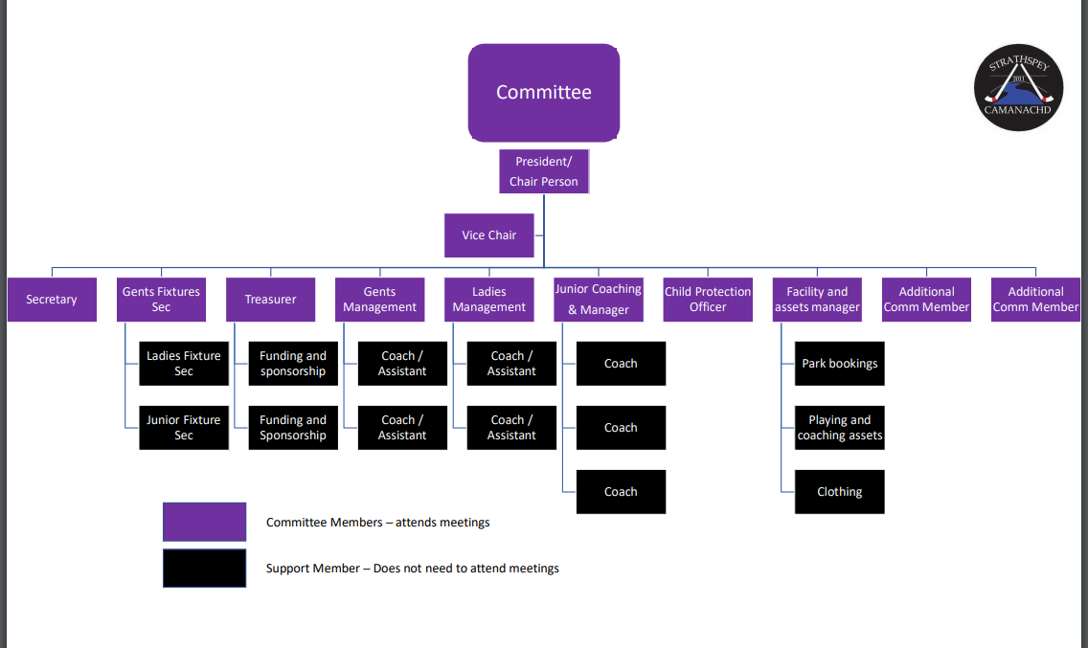

Appendix B – Club Vision

