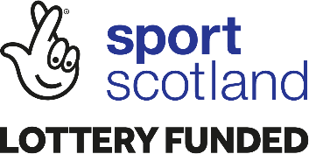
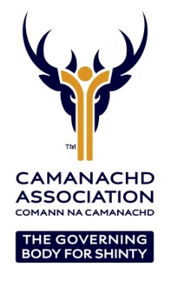
REGIONAL SHINTY DEVELOPMENT OFFICER – WEST
Full time permanent post starting in January 2021.

- Location: Home office, Argyll
- Hours: 37.5 per week with a flexible work pattern
- Salary: £23,000 per annum + Pension contribution

The Camanachd Association is the Governing Body for shinty and our objective is to protect and enhance shinty as a vibrant and integral part of Scottish life. As part of that vision the post holder will be responsible for working with local partners to grow the game of shinty. Ensuring our values, our operating principles, equality and inclusion are at the heart of that work continues to be a core aspect of our role. If you are interested and passionate about making a difference, if you are keen to support local communities enhancing the opportunities available in shinty then we want to hear from you.

The Camanachd Association, in partnership with sportscotland and Argyll and Bute Council, wish to appoint, on a permanent basis, a Regional Shinty Development Officer for the West Region to lead the Association’s plan for the promotion and development of shinty in Argyll. This is an important role with a particular emphasis on Youth Development, Club & Volunteer Development and Coach/ Official Education. The successful applicant will work with partners to build on existing programmes and lead the development of a range of new initiatives to promote and develop the game.

The position requires the individual to work flexible hours, with travel required throughout the region. Partnership working is essential to success, in particular with the local shinty clubs, the Active school’s network, Primary and Secondary schools, plus Local Authorities and Leisure Trusts

This is a challenging role that would suit an individual with a “can do” approach to their work, a good understanding of the challenges and solutions to sports development and a passion for sports participation. The successful candidate will require excellent organisation, attention to detail, communication skills and must also be able to demonstrate success in managing projects in partnership through to completion.

The detailed Job Description, including Person Specification, can be downloaded from
www.shinty.com or requested from the Camanachd Association office on 01463 715931.

Interested individuals should submit a CV and covering letter detailing why they would like to be considered for the position in relation to the job description, person specifciation and our strategic priorities. Closing date for applications is 9am on Wednesday 24th November 2021. Interviews will be held on Friday 3rd December 2021.

The Camanachd Association are committed to the promotion of equality of opportunity. It intends that no job applicant or employee shall receive less favourable treatment because of sex, marital or family status, age, ethnic origin, disability, race, colour, nationality, religion or belief, sexual orientation, or any other non-job-related factor. Through our Equal Opportunities Policy and its implementation, the Camanachd Association seeks to ensure that the talents and skills of its employees are utilised to the full, to the benefit of the organisation and its employees. Completed applications should be marked ‘Private & Confidential’ and sent to: Graham Cormack, National Development Manager: 01463 715931 graham.cormack@shinty.com The Camanachd Association, PO Box 5805, INVERNESS. IV1 9FX

