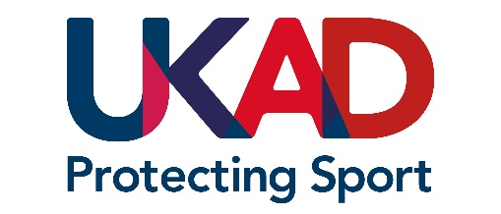
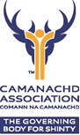
1st October 2021
National Squad Players and Support Personnel

Dear All
Prohibited List update information

The Camanachd Association, as part of its commitment to Clean Sport and the UKAD Assurance Framework, would like to communicate to our performance pathway players and support personnel about changes to the Prohibited List.

The World Anti-Doping Agency (WADA) has now published the 2022 Prohibited List, available on the WADA website WADA publishes 2022 Prohibited List | World Anti-Doping Agency (wada-ama.org)

The Prohibited List identifies which substances and methods are prohibited at all times, in-competition only, and within specific sports.

All Players and Player Support Personnel are advised to familiarise themselves with the new changes in advance of them coming into effect on 1 January 2022. UKAD has also published a summary and infographic of the major changes which are available on Major Changes to the 2022 Prohibited List: What you need to know | UK Anti-Doping (ukad.org.uk)

With kind regards
Graham Cormack
National Development Manager
The Camanachd Association
PO Box 5805
INVERNESS
IV1 9FX
Tel: 01463 715931
Mob: 07894 588538
graham.cormack@shinty.com

