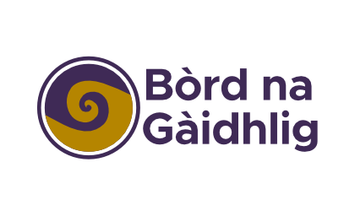
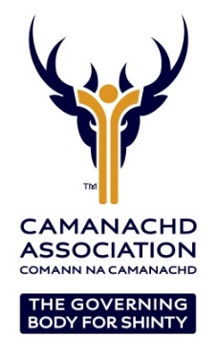

GAELIC LANGUAGE SHINTY DEVELOPMENT OFFICER
ISLE OF SKYE
Part time fixed term (12 months) post starting in August 2022.

- Location: Home office, Isle of Skye
- Hours: 17.5 per week with a flexible work pattern
- Salary: £12,000 per annum + Pension contribution

The Camanachd Association is the Governing Body for shinty and our objective is to protect and enhance shinty as a vibrant and integral part of Scottish life. As part of that vision the post holder will be responsible for working with local partners to grow the Gaelic language through the game of shinty. Ensuring our values, our operating principles, equality and inclusion are at the heart of a focused piece of work to grow the sport. If you are interested and passionate about making a difference, if you are keen to support local communities enhancing the opportunities available in the Gaelic language through shinty then we want to hear from you.

The Camanachd Association, with support from Bòrd na Gàidhlig, wish to appoint, on a fixed term basis, a Gaelic Language Shinty Development Officer for the Isle of Skye to lead the Association’s plan for the promotion and development of shinty. There is a specific focus on growing the number of people using and benefiting from Gaelic, at home and in the community. The post will aim to create opportunities for adults and youths to develop their Gaelic skills at any age and profile more people in Scotland positively engaging with the Gaelic language and culture. This will be done through the provision of shinty.
The successful applicant will target Gaelic communities and schools to develop new opportunities in shinty that didn’t previously exist. The objective is to provide sporting opportunities in a Gaelic sport using the Gaelic language to coach and deliver the sessions thus providing a regular opportunity for participants to use their language out with the school environment.

The position requires the individual to work flexible hours, with travel required throughout the island. Partnership working is essential to success, in particular with Skye Camanachd, the Active school’s network, Primary and Secondary schools, plus Local Authorities and Leisure Trusts. The successful applicant will also play a lead on the Culture and Heritage Portfolio group for the Camanachd Association

This is a role that would suit an individual with a “can do” approach to their work, a good understanding of the challenges and solutions to sports development and a passion for sports participation. The successful candidate will require excellent organisation, attention to detail, communication skills (both in Gaelic and in English) and must also be able to demonstrate success in project delivery through to completion.

The detailed Job Description, including Person Specification, can be downloaded from
www.shinty.com or requested from the Camanachd Association office on 01463 715931.

Interested individuals should submit a CV and covering letter detailing why they would like to be considered for the position in relation to the job description, person specification and our strategic priorities. Closing date for applications is 9am on Friday 29th July 2022.
Interviews will be held on the week beginning 8th August 2022.

The Camanachd Association are committed to the promotion of equality of opportunity. It intends that no job applicant or employee shall receive less favourable treatment because of sex, marital or family status, age, ethnic origin, disability, race, colour, nationality, religion or belief, sexual orientation, or any other non-job-related factor. Through our Equal Opportunities Policy and its implementation, the Camanachd Association seeks to ensure that the talents and skills of its employees are utilised to the full, to the benefit of the organisation and its employees. Completed applications should be marked ‘Private & Confidential’ and sent to……

